**Module 4**

Andrew Siekmann

Colorado State University Global

CSC 500-1 Principles of Programming

Lori Farr

3/6/2024

**Figure 1**

**Code, Execution, Output**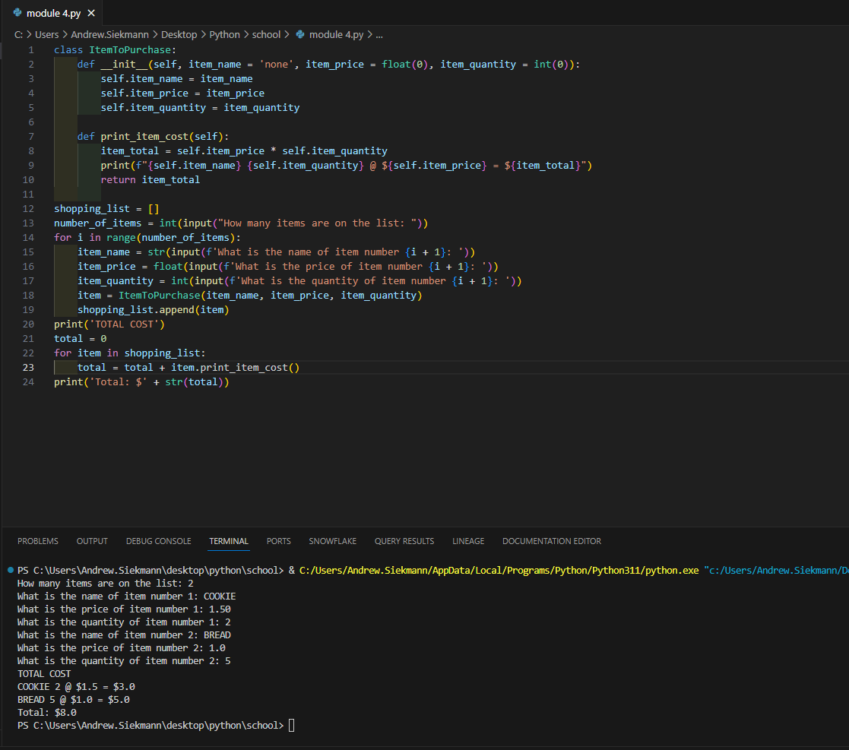

**Git Repository**

<https://github.com/siekmann-school/csc500-4>